**Visit to Dist. Court Rohtak**

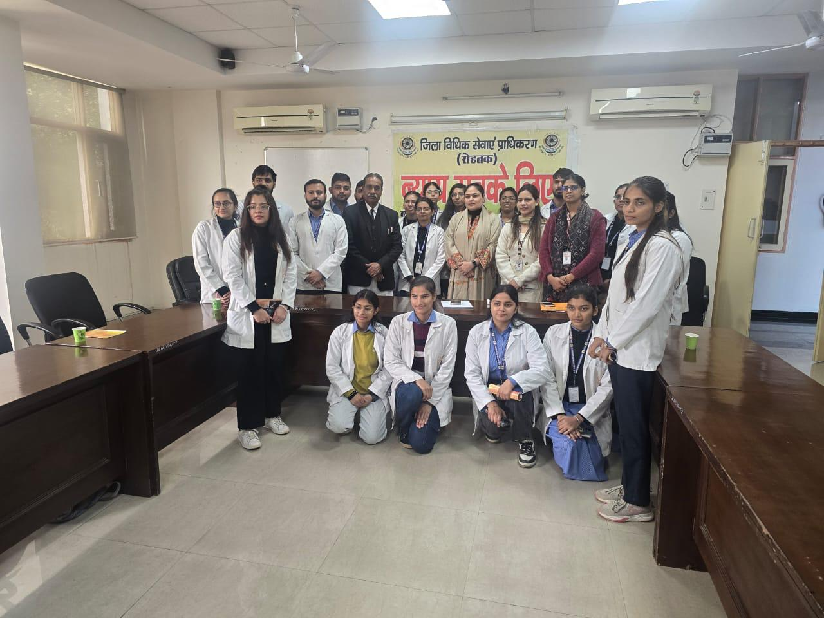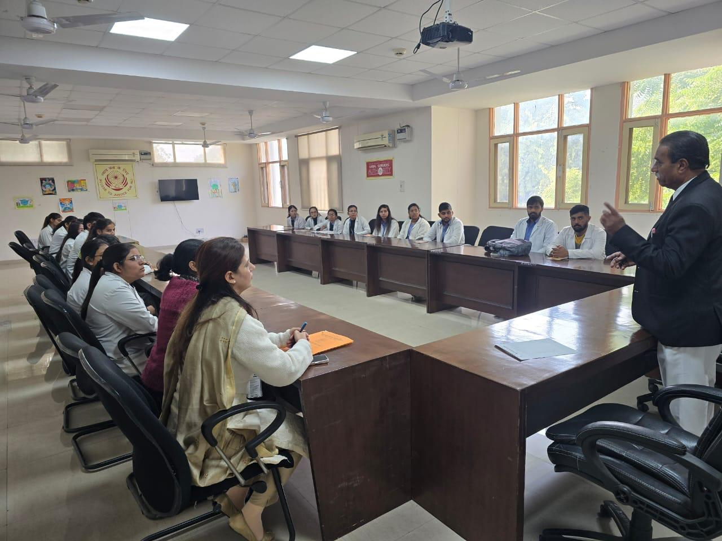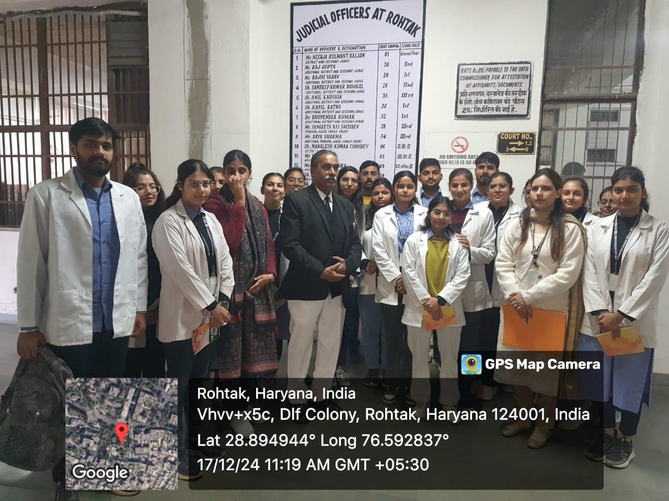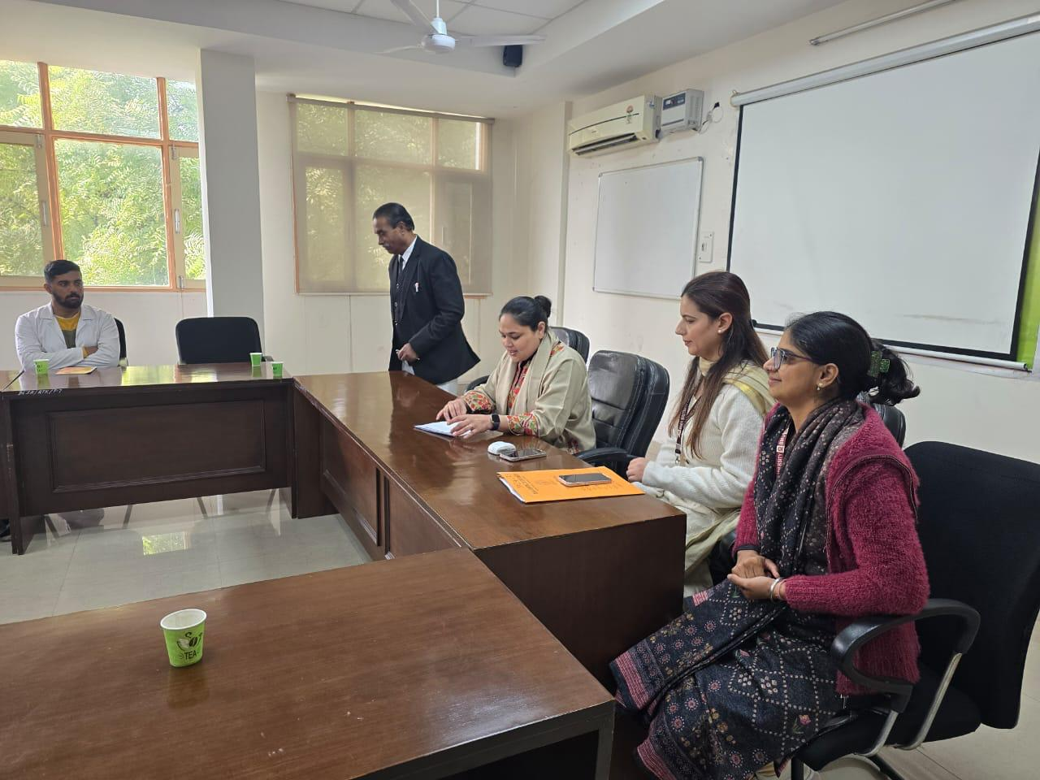On December 12, 2024, BAMS students from SBMN, under the mentorship of Dr. Nisha, participated in an educational trip organized at the Rohtak District Court. The primary objective of this event was to offer students practical experience and insight into the intricacies of the legal system. The students were greeted by Rajbir Kashyap, Deputy Chief Legal Aid Défense Council of DLSA, who introduced them to the court's procedures, including the eleven lower sessions present and the various functions performed by the court. Rajveer Kashyap also shared the background of the Bhanwari Devi case and the Visakha guidelines, as well as the story of Kevin Carter, a photographer, to provoke thoughtful discussion. Subsequently, the students observed a murder case hearing presided over by Judge Neeraj Kulwant in the Session Court. During this session, forensic expert Dr. Saroj Dahiya provided testimony regarding the Makroli Kalan murder case. Additionally, the students witnessed another case under the POCSO Act by Judge Raj Gupta's court. Following these observations, the students received comprehensive information about legal provisions and amendments in the conference hall. Rajveer Kashyap discussed Article 39, which was added through the Constitutional Amendment of 1976, highlighting that individual earning less than three lakh annually, along with women and minorities, are entitled to free legal aid, as established in 2007. In conclusion, the students had the opportunity to meet Mrs. Tarannum Khan, Chief Judicial Magistrate and Secretary of the District Legal Services Authority, who elaborated on the complexities of the judicial system. BAMS students Riya, Kritika, and Anjali, who participated in the tour, expressed that witnessing court proceedings firsthand was an enlightening experience that surpassed their academic learning. They noted that the forensic report and the murder case presented by Dr. Saroj Dahiya illustrated the collaboration between law and science in delivering justice, emphasizing the value of such initiatives for students.

